**BASAK**



[*Default*](https://mail.google.com/mail/data/u/0/)

[*BASAK*](https://mail.google.com/mail/data/u/0/)

[*basakcolaaak@gmail.com*](https://mail.google.com/mail/data/u/0/)

[All Brand accounts](https://myaccount.google.com/brandaccounts?authuser=0&continue=https://mail.google.com/mail&service=/mail/data/u/%24session_index/)

Delete forever

Not spam

More

# Yurtdışı Eğitim Seminerleri ve Yüzlerce Burs Fırsatı

|  |  |  |
| --- | --- | --- |
| **Academix mailer@academix.com.tr** [**via**](https://support.google.com/mail/answer/1311182?hl=en) **cp20.com** | Wed, Mar 17, 11:03 AM (6 days ago) |  |

|  |  |  |
| --- | --- | --- |
| to me    from: reply-to: to: date: subject: | Academix <mailer@academix.com.tr> [via](https://support.google.com/mail/answer/1311182?hl=en) cp20.com Academix <reply_tasuwn_gngdamqg_o@cp20.com>  basakcolaaak@gmail.com Mar 17, 2021, 11:03 AM  Yurtdışı Eğitim Seminerleri ve Yüzlerce Burs Fırsatı |  |

Spam

mailed-by: cp20.com signed-by: cp20.com security: Standard encryption (TLS) [Learn more](https://support.google.com/mail?hl=en&p=tls)

# Be careful with this message

Gmail could not verify that it actually came from academix.com.tr. Avoid clicking links, downloading attachments, or replying with personal information.

Looks safe

Turkish

English

Translate message

Turn off for: Turkish

Bu e-maili düzgün görüntüleyemiyorsanız lütfen tıklayın.

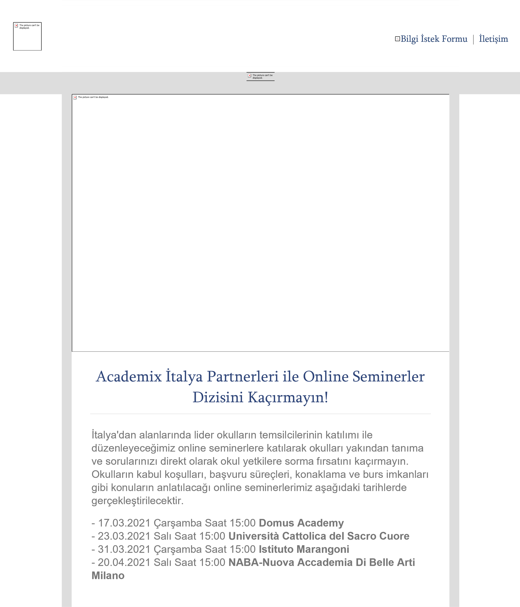

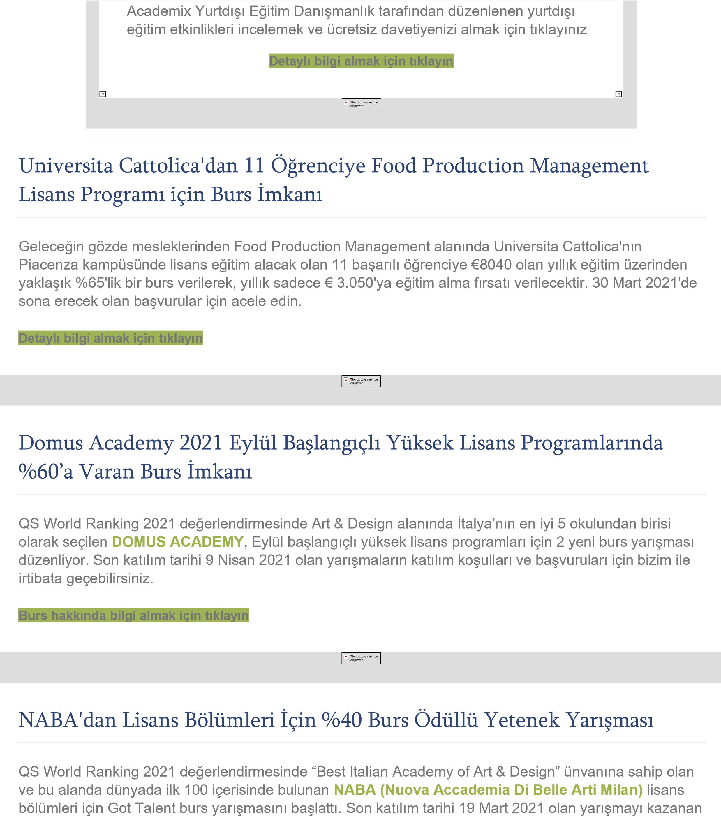

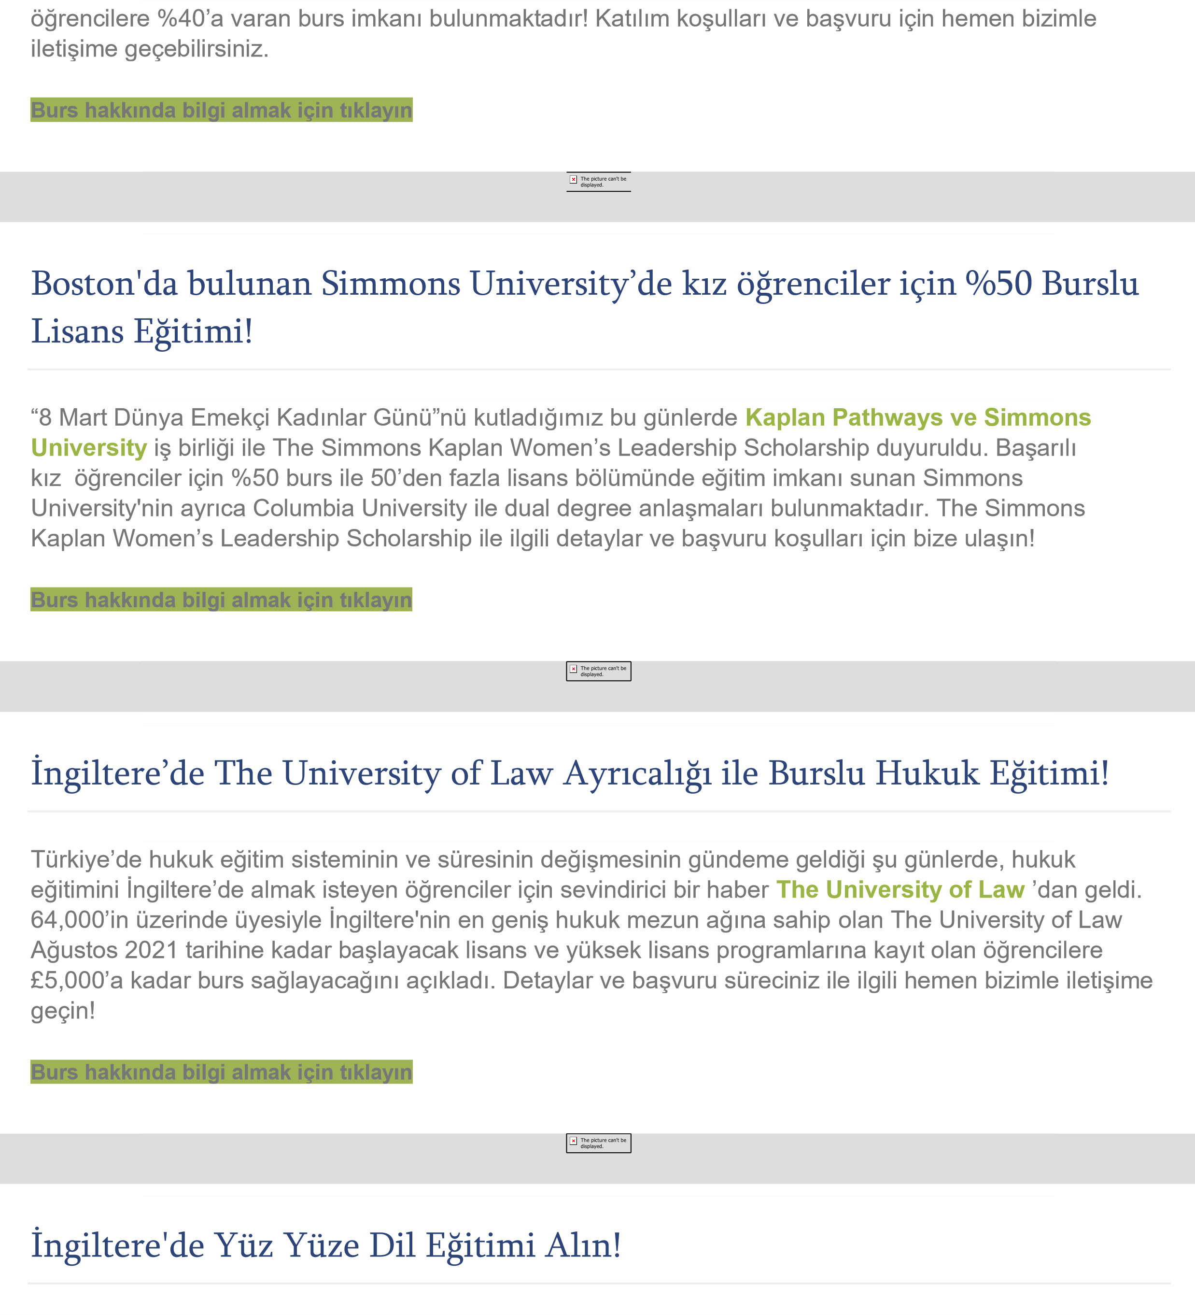

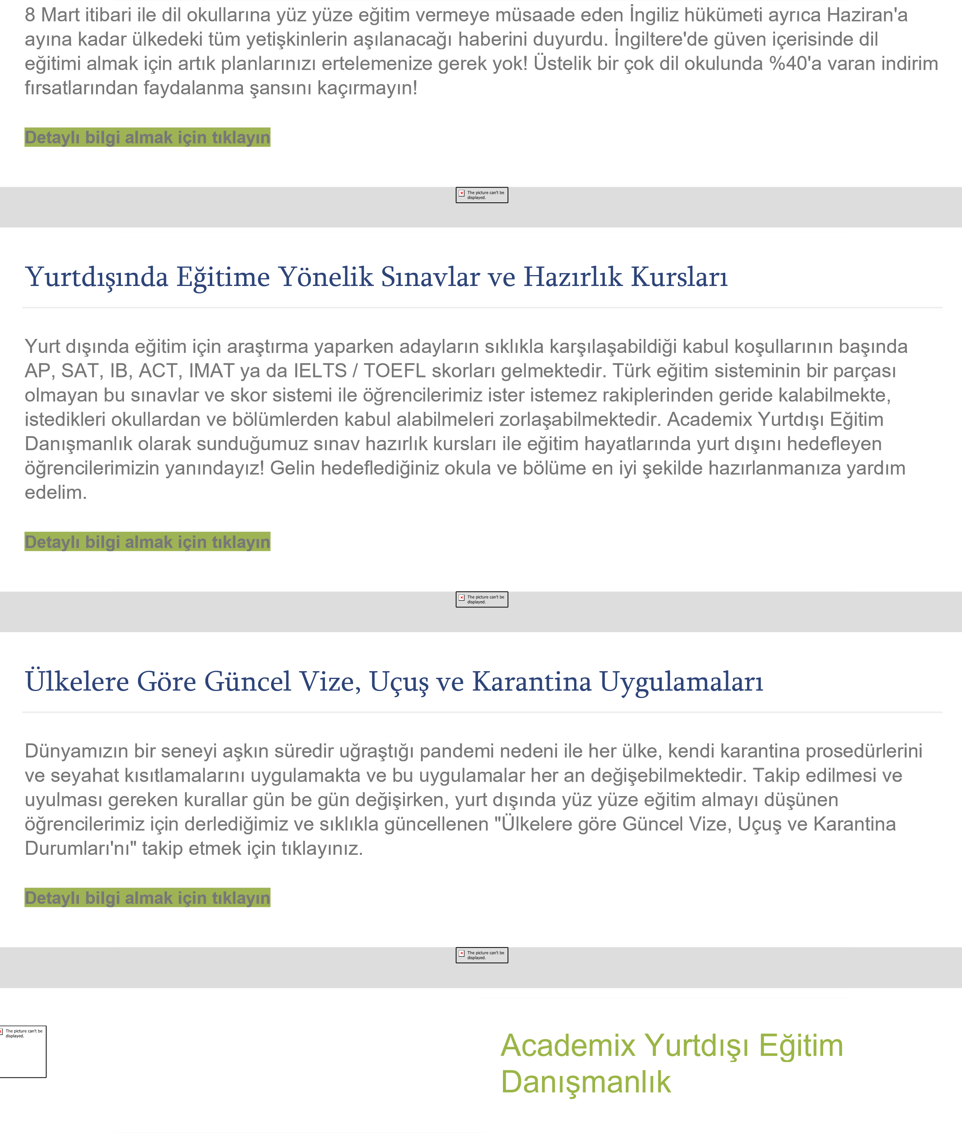

Reply ForwardReplyForward

Search

Clear search

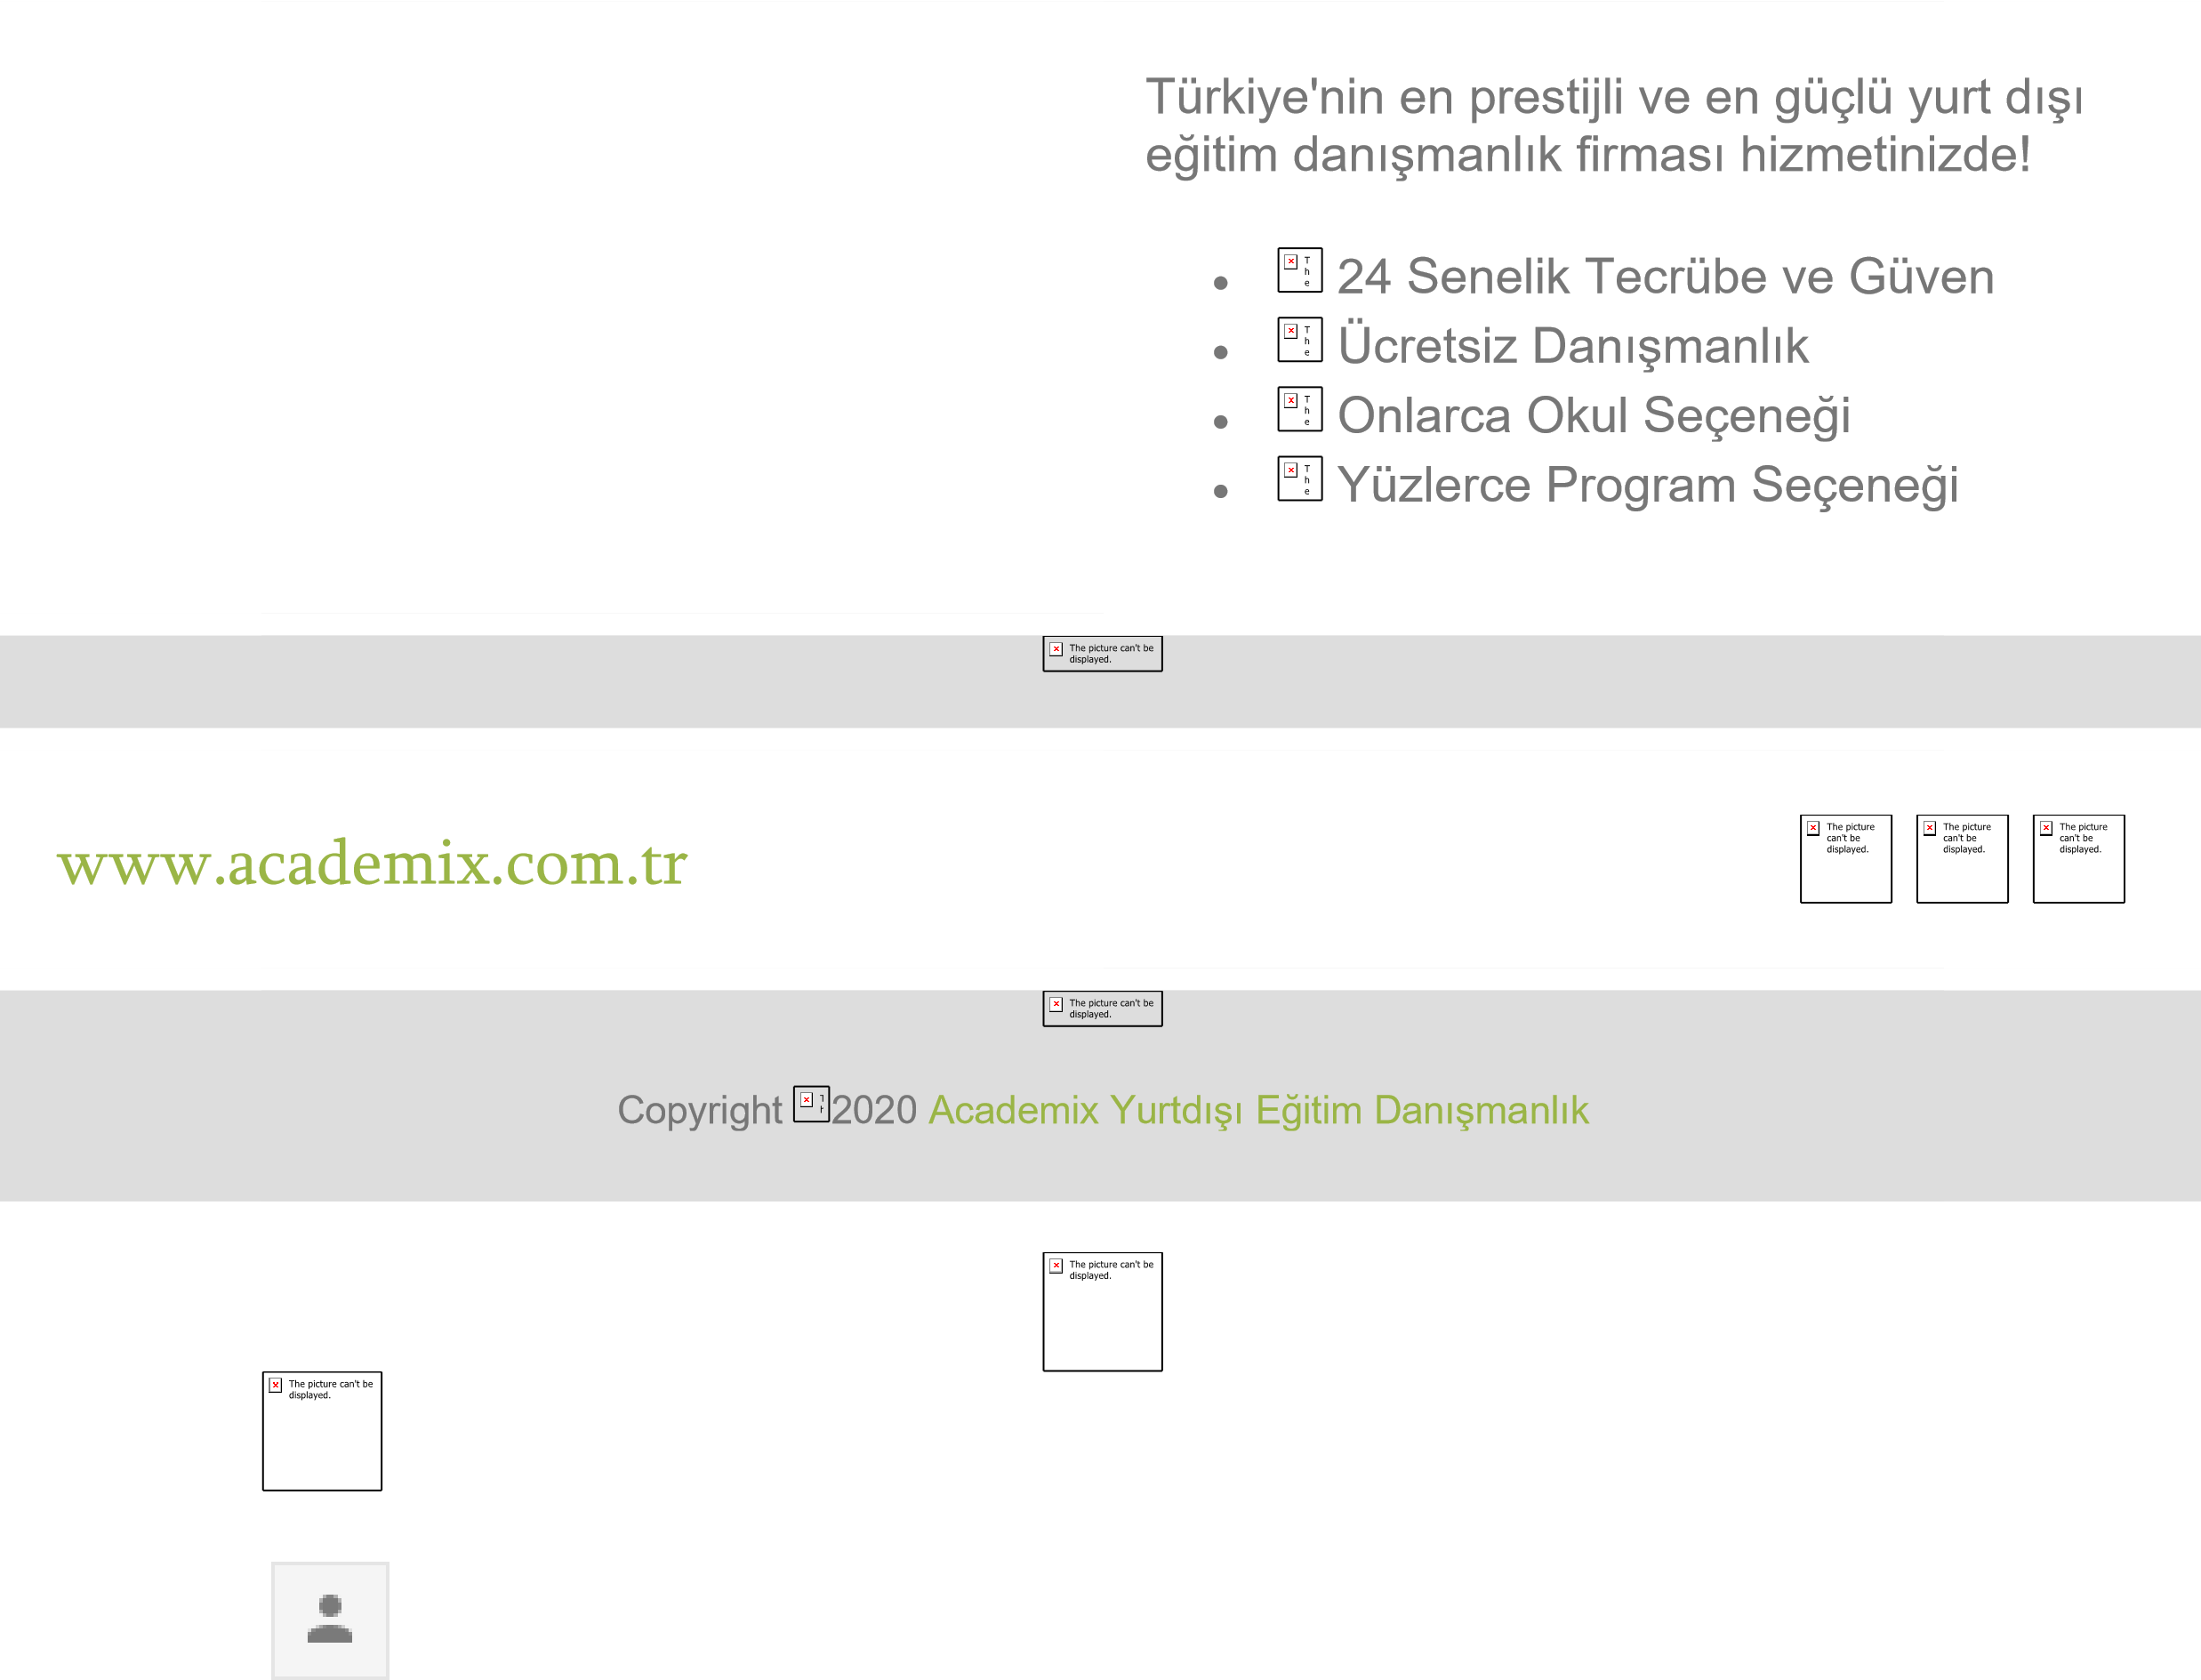Close search

Main menu

Google Account

BASAK

basakcolaaak@gmail.com Google apps